User View Analysis Name - K V Santhosh
Roll Number - AP23110010212
A User View Analysis breaks down the system from the perspective of the people (and systems) interacting with it. In this project, we have strictly defined Role-Based Access Control (RBAC) , meaning each user experiences a completely different "view" of the platform tailored to their responsibilities.

1. The Citizen View (The Initiator)
- Perspective: The citizen wants a frictionless, transparent way to report community issues without dealing with government bureaucracy.
- Capabilities: They register/log in securely, upload photos of issues, and the system automatically tags their GPS location and profile info .
- Interface Experience: A simple mobile-friendly dashboard where they can submit tickets and view a timeline of their own tickets' statuses (Pending, Assigned, Resolved) . They do not see internal routing mechanics.

2. The Admin View (The Traffic Controller)
- Perspective: The Admin is the operational core of the system. They need a high-level view of incoming reports to ensure the AI hasn't made a mistake and that resources are allocated correctly.
- Capabilities: They review tickets in the PENDING_ADMIN state, verify the AI's department recommendation (and confidence score), and assign the ticket to a specific Worker . They also act as the final judge for "False Reports" flagged by workers . Furthermore, they manage the master data (creating new departments and user accounts) .
- Interface Experience: A complex command-center dashboard with queues, worker availability lists, and master data CRUD (Create, Read, Update, Delete) tables .

3. The Department Worker View (The Executor)
- Perspective: The Worker is on the ground. They don't want to see every ticket in the city—only the ones assigned to them so they can do their job and prove it's done.
- Capabilities: They receive a filtered list of tickets with the ASSIGNED status. They travel to the location, fix the issue, and upload an "After" photo as proof of resolution. If the ticket is a prank, they flag it as a "False Report" and provide reasoning.
- Interface Experience: A highly focused, task-oriented list view with large buttons for uploading images and adding resolution notes .

4. The Officer View (The Executive)
- Perspective: The Officer is a supervisor or mayor figure. They do not resolve individual tickets; they monitor the overall efficiency of the city's departments.
- Capabilities: They have entirely read-only access to aggregated data.
- Interface Experience: A purely analytical dashboard filled with KPI cards (total tickets, average resolution time), pie charts, and SLA compliance metrics .

5. The AI Classification Service (System Actor)
- Perspective: An automated background entity.
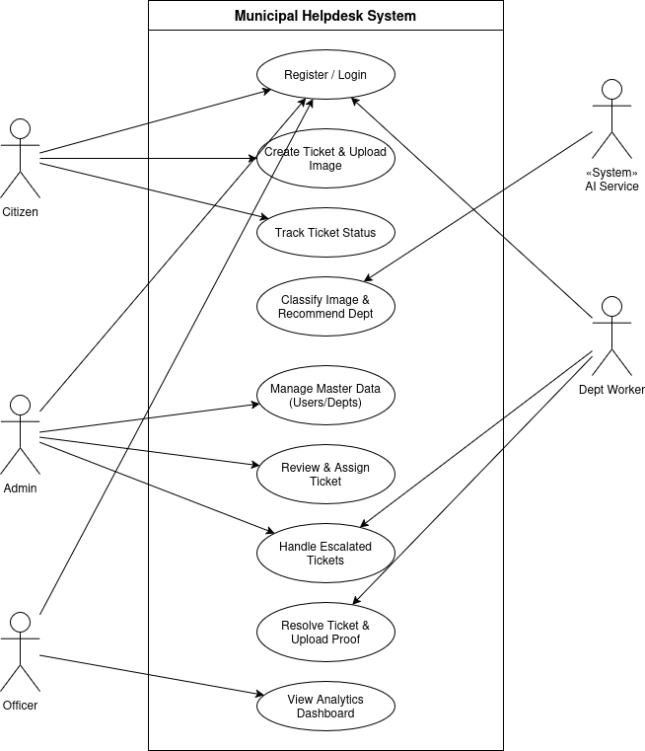
- Capabilities: It "listens" for new ticket images, analyzes them, and predicts the correct municipal department (Water, Roads, etc.), returning a confidence score .

